

**MASTER OF COMPUTER APPLICATION(MCA)**

(BATCH:2022-2024)

**WEB TECHNOLOGIES LABORATORY**

**(Course Code:PGCA1914)**

**SUBMITTED TO: SUBMITTED BY:**

**NAME: Mrs. Gurmandeep Kaur NAME:ARUN TIWARI**

**Assistant Professor ROLL NO. :2235545**

**SEMESTER:2nd**

**DEPARTMENT:MCA**

**INDEX**

|  |  |  |  |  |
| --- | --- | --- | --- | --- |
| **Sr. No.** | **Topic** | **Page No** | **Date of Submission** | **Signature** |
| **1** | **Design a simple HTML page of a book Titled Web Designing.** |  |  |  |
| **2** | **Create a simple HTML page to demonstrate the use of different tags.** |  |  |  |
| **3** | **Display Letter Head of your college on a web page & it must be scrolling Right to Left.** |  |  |  |
| **4** | **Create a link to move within a single page rather than to load another page.** |  |  |  |
| **5** | **Display “Name of University” using different Text formatting Tags.** |  |  |  |
| **6** | **Design Time Table of your department and highlight most important periods.** |  |  |  |
| **7** | **Use Tables to provide layout to your web page.** |  |  |  |
| **8** | **Embed Audio and Video into your web page.** |  |  |  |
| **9** | **Divide a web page vertically and display logo of your college in left pane and logo of university in right pane.** |  |  |  |
| **10** | **Create Bio- Data of an employee.** |  |  |  |
| **11** | **Design front page of a hospital with different styles.** |  |  |  |
| **12** | **Design a web page and display horizontally two different web pages at a time.** |  |  |  |
| **13** | **Write a program to create a login form. On clicking the submit button, the user should get navigated to a profile page.** |  |  |  |
| **14** | **Write a HTML code to create a Registration Form. On submitting the form, the user should be asked to login with the new credentials** |  |  |  |
| **15** | **Write a HTML code to create website in your college or department and create link for Tutorial of specific subject** |  |  |  |
| **16** | **Write a program to perform following operations on two numbers input by the user: Addition 2) Subtraction 3) Multiplication 4) Division.** |  |  |  |
| **17** | **Design a program to solve quadratic equations.** |  |  |  |
| **18** | **Write a program to determine greatest number of three numbers.** |  |  |  |
| **19** | **Write a script to compute, the Average and Grade of students marks.** |  |  |  |
| **20** | **Design a scientific calculator and make event for each button using scripting language.** |  |  |  |
| **21** | **Write a script to check whether a number is even or odd?** |  |  |  |
| **22** | **Write a program to show whether a number is prime or not?** |  |  |  |
| **23** | **Write a program to show multiplication table of any number.** |  |  |  |
| **24** | **Write a program to find the factorial of any number** |  |  |  |
| **25** | **Write a program to show Fibonacci Series between 0 to 74.** |  |  |  |

**Program no. 1**

Design index page of a book Title web Designing.

<!DOCTYPE html>

<html>

<head>

    <title>Index Page</title>

    <style>

        table{

            margin-left:auto;

            margin-right:auto;

            margin-top:50px;

            width:40%;

            text-align:left;

            border-radius:15px;

            padding:35px;

            box-shadow:5px 5px 50px #000;

            background-color:#e0eaff;

            }

        tr:hover{

        background-color:#ababab33;

        }

        .k{

            text-align: center;

            font-size: 29px;

            padding-bottom: 23px;

        }

    </style>

</head>

<body>

    <table>

    <tr><th colspan=3 class ="k">Content    </th></tr>

        <tr>

            <th>S.NO</th>

            <th>Name Of The Topic</th>

            <th>Page.NO</th>

        </tr>

        <tr>

            <td>01</td>

            <td>HTML Introduction</td>

            <td>1</td>

        </tr>

        <tr>

            <td>02</td>

            <td>HTML Editor</td>

            <td>2</td>

        </tr>

        <tr>

            <td>03</td>

            <td>HTML Basic</td>

            <td>3</td>

        </tr>

        <tr>

            <td>04</td>

            <td>HTML Elements</td>

            <td>4</td>

        </tr>

        <tr>

            <td>05</td>

            <td>HTML Attributes</td>

            <td>5</td>

        </tr>

        <tr>

            <td>06</td>

            <td>HTML Headings</td>

            <td>6</td>

        </tr>

        <tr>

            <td>07</td>

            <td>HTML Paragraphs</td>

            <td>7</td>

        </tr>

        <tr>

            <td>08</td>

            <td>HTML Styles</td>

            <td>8</td>

        </tr>

        <tr>

            <td>09</td>

            <td>HTML Formatting</td>

            <td>9</td>

        </tr>

        <tr>

            <td>10</td>

            <td>HTML Colors</td>

            <td>10</td>

        </tr>

    </table>

    <a href="MainIndex.html">HOME</a>

    <a href="differenttags.html" style="float:right">NEXT</a>

</body>

</html>

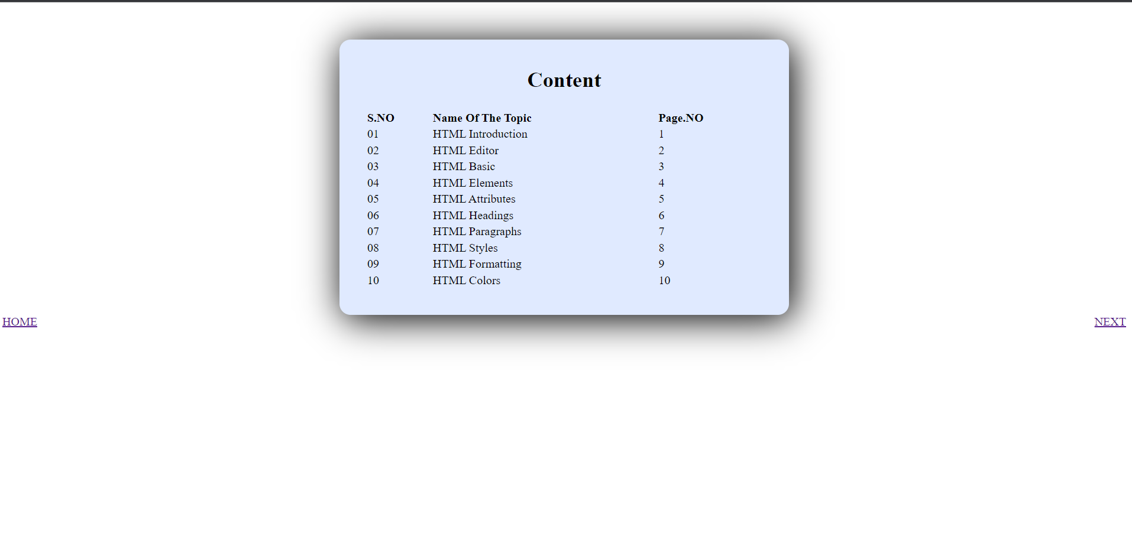

**Program no. 2**

Create a simple HTML page to demonstrate the use of different tags.

!DOCTYPE html>

<html>

    <head>

        <title>Use of different Tags</title>

    </head>

    <style>

        .yy{

            margin-top: 20px;

        }

        table{

            width: 100%;

            text-align: left;

        }

        .j{

            width:30%;

        }

    </style>

    <body>

        <table>

            <tr>

                <th class="j">Tags</th>

                <th>Description</th>

            </tr>

            <tr>

                <td>1. h1 to h6</td>

                <td>Defines HTML headings</td>

            </tr>

            <tr>

                <td>2. !DOCKTYPE</td>

                <td>Defines the document type</td>

            </tr>

            <tr>

                <td>3. a</td>

                <td>Defines a hyperlink</td>

            </tr>

            <tr>

                <td>4. bdo</td>

                <td>Overrides the current text direction</td>

            </tr>

            <tr>

                <td>5. br</td>

                <td>Defines a single line break</td>

            </tr>

            <tr>

                <td>6. button</td>

                <td>Defines a clickable button</td>

            </tr>

            <tr>

                <td>7. div</td>

                <td>Defines a section in a document</td>

            </tr>

            <tr>

                <td>8. footer </td>

                <td>Defines a footer for a document or section</td>

            </tr>

            <tr>

                <td>9. img </td>

                <td>Defines an image</td>

            </tr>

            <tr>

                <td>10. label</td>

                <td>Defines a label for an element</td>

            </tr>

    </table>

    <div class="yy">

    <a href="Indexpage.html">PREVIEW</a>

    <a href="latterhead.html" style="float:right">NEXT</a>

</div>

    </body>

</html>

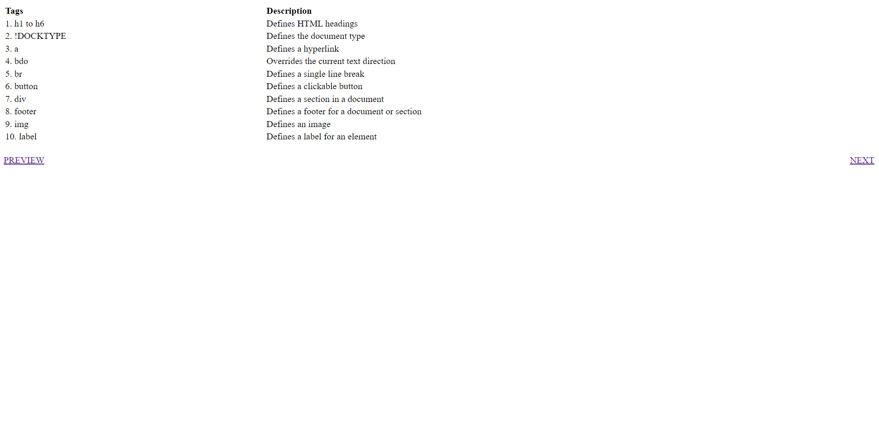

**Program no.3**

Display Letter Head of your college on a web page & it must be scrolling Right to Left.

<!DOCKTYPE html>

<html>

    <head>

        <title>LETTER HEAD</title>

        <style>

            h1

            {

                    text-transform:uppercase;

            }

            h6{

                margin:-20px;

            }

            img

            {

                width:150px;

                height:120px;

                float:left;

            }

            .ar{

                float:left;

                margin:0px 50px 0px 0px;

            }

            .ba{

                float:right;

                margin:0px 50px 0px 0px;

            }

            h3{

                text-align:center;

                margin-top:50;

                font-weight:600px;

            }

            .lt{

                width:900px;

                line-height: 35px;

                margin-left:auto;

                margin-right:auto;

                box-shadow:5px 5px 90px;

                margin-top: 25;

                padding: 25px;

            }

        </style>

    </head>

    <body>

        <div class="lt">

            <img src="CGC_logo.jpeg" alt="logo">

        <div>

            <h1>chandigarh<br> <u>school of business</u></h1>

            <h6>Building Careers Transforming Lives</h6>

            <h2>

                Jhanjeri,Mohali

            </h2>

            <h6 class="ar">

                Ref.no.CSB/22-23/310

            </h6>

            <h6 class="ba">Date:04/03/2023</h6>

            <h3><b><u>Notice</u></b></h3>

        </div>

        <p>

            All faculty memwwbers and students are hereby informed that MST-1.<br>

            Examintion for all the semester will be commenced from 13<sup>th</sup> to 15<sup>th</sup> March 2023.

        </p>

        <b>Director</b><br>

        <b>Chandigarh School Of Business<br>Jhanjeri , Mohali</b>

         <p><b>CC:</b></p>

        <ol>

            <li>Hon'ble management through Mr.Krishan Sharma (PA to mangement)</li>

            <li>Hon'ble Executive Director through Mr.rohit Monga(EA To ED)</li>

            <li>Dean Computer Sci.</li>

            <li>All HOD of CSB</li>

            <li>Centre Superintendent</li>

        </ol>

        </div>

        <a href="differenttags.html">PREVIEW</a>

        <a href="taxtFormatting.html" style="float:right">NEXT</a>

    </body>

</html>

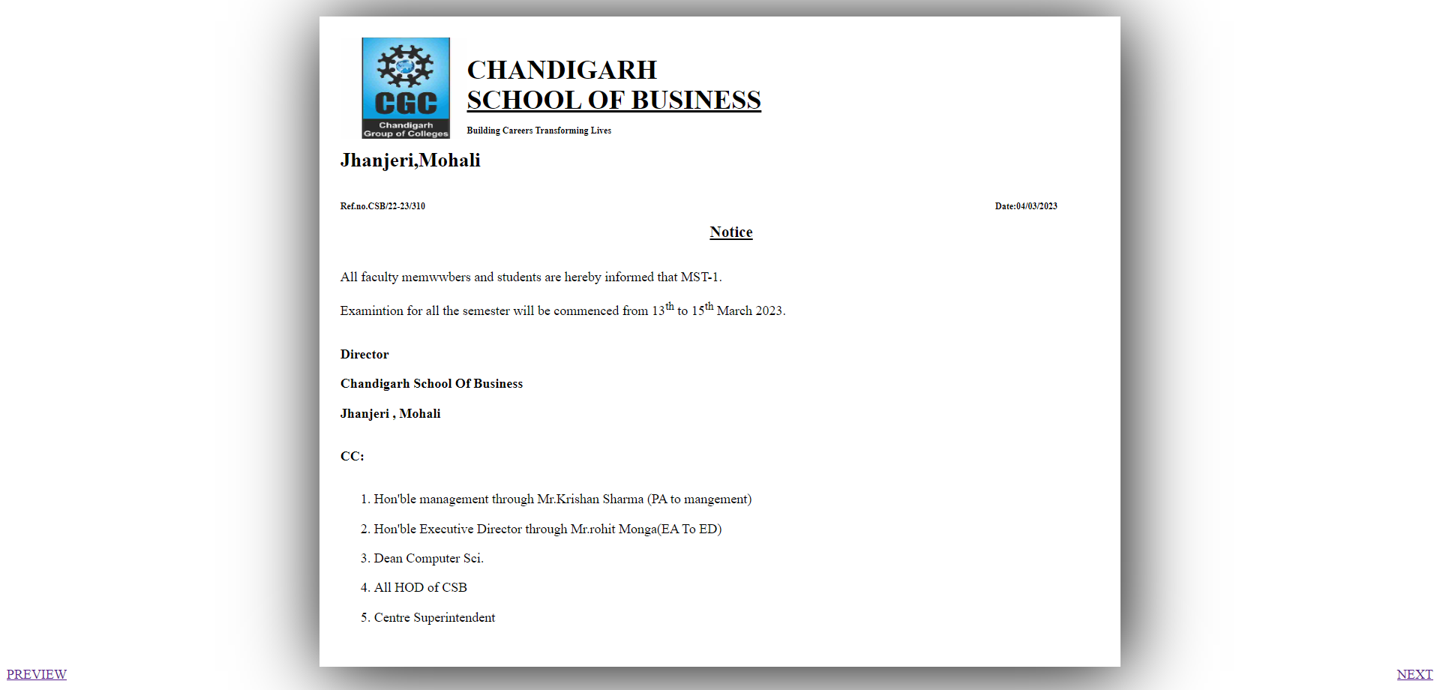

**Program no.4**

Create a link to move within a single page rather than to load another page.

<!DOCTYPE html>

<html>

    <head>

        <title></title>

    </head>

    <style>

        *{

            text-decoration: none;

            color: black;

            padding-left: 25px;

        }

        .j{

            text-align: center;

            text-decoration: underline;

        }

        h3{

            text-decoration: underline;

        }

    </style>

    <body style=background-color:grey">

        <h1 class="j"><u>CSS</u></h1>

        <h3><a href="#e">Introduction of CSS</a></h3>

        <h3><a href="#a">Why need CSS</a></h3>

        <h3><a href="#b">Syntax and Property</a></h3>

        <h3><a href="#c">Selector</h3>

        <h3><a href="#d">Types of CSS</h3><br>

        <h3 id="e">Introduction of CSS </h3>

        <p> Cascading Style Sheets.<br>

            Cascading : refers to the procedure that determines which style will    apply   to a certain section, if you have more than one style rull.<br>

            Style : How you want a certain part of your pages to look.you can set   things  like color, margins, font, etc for things like tables, paragraphs, and  headings.<br>

            Sheets: Sheets are templates, or a set of rules, for determining how the    webpage will looks.<br>

            The first version of CSS was invented 1996 by Hakon Wium Lie.</p>

<br>

<h3 id="a">Why need CSS</h3>

        <p>Design pages.<br>

            Makes webpage Beautifull anduser interfaces.<br>

            control the layout of multiple web  pages all at once.<br>

            layout and variations in display for    different devices and screen sizes.<br>

            you can control the color of the text.<br>

            style of fonts, spacing between paragraphs, background images or colors.<br>

        </p>

<br>

<h3 id="b">Syntax and Property</h3>

        <p>CSS code is written inside {} curly brackets<br>

        h1{color: red }<br>

        h1   : is Selector<br>

        color: is Property<br>

        red  : is value

        </p>

<br>

<h3 id="c">Selector</h3>

        <p>

            ELEMENT Selector : The element selector select HTML element based on the element name.<br>

            p{Property:value}<br>

            CLASS Selector   :To select the element with a particul of class,use(.)<br>

            character with specifying the class name.<br>

            .class_name{Property:value}<br>

            ID Selector      :The id attribute is the unique identifier in an HTML document.<br>

            The id Selector is used with a # character.

        </p>

<br>

<h3 id="d">Types of CSS</h3>

        <p>

            1.Inline CSS<br>

            2.Internal or Embedded CSS<br>

            3.External CSS

        </p>

        <a href="program3.html">PREVIEW</a>

        <a href="program5.html" style="float:right">NEXT</a>

    </body>

</html>

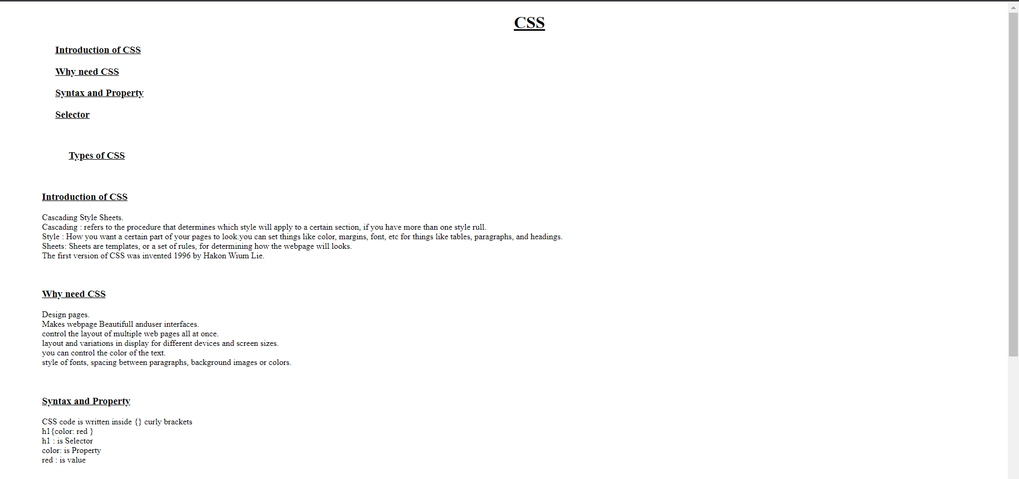

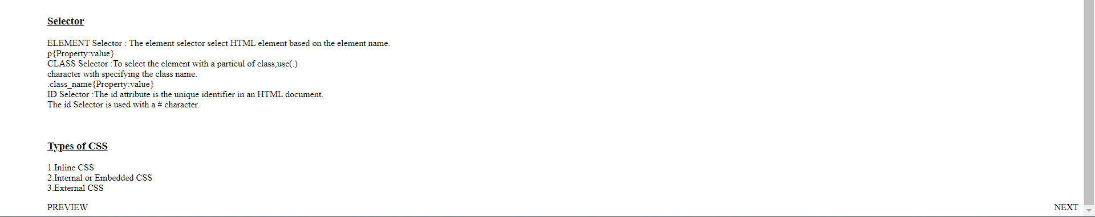

**Program no.5**

Display “Name of University” using different Text formatting Tags.

<!DOCKTYPE html>

<html>

<head>

<title>Text Formatting Tags</title>

    <style>

    h1  {text-align:center;}

    h1  {font-size:50px;}

    h1{text-shadow:2px 3px 2px lightblue;}

    h2{text-align:left;}

    p{text-align:left;}

    </style>

<body>

    <h1><u>Punjab Technical University</u></1>

    <h2>Punjab Technical University</h2>

    <h3>Punjab Technical University</h3>

    <h4>Punjab Technical University</h4>

    <h5>Punjab Technical University</h5>

    <h6>Punjab Technical University</h6>

    <p> <i>Punjab Technical University</i></p>

    <p> <b>Punjab Technical University</b></p>

    <p> <u>Punjab Technical University</u></p>

    <p> <strong>Punjab Technical University</strong></p>

    <p> <tt>Punjab Technical University</tt></p>

    <p> <strike>Punjab Technical University</strike></p>

    <p> Punjab<sub> Technical University</sub></p>

    <p> Punjab<sup> Technical University</sup></p>

    <h3>Punjab<mark> Technical</mark> University</h3>

    <a href="program4.html">PREVIEW</a>

    <a href="program6.html" style="float:right">NEXT</a>

</body>

</head>

</html>

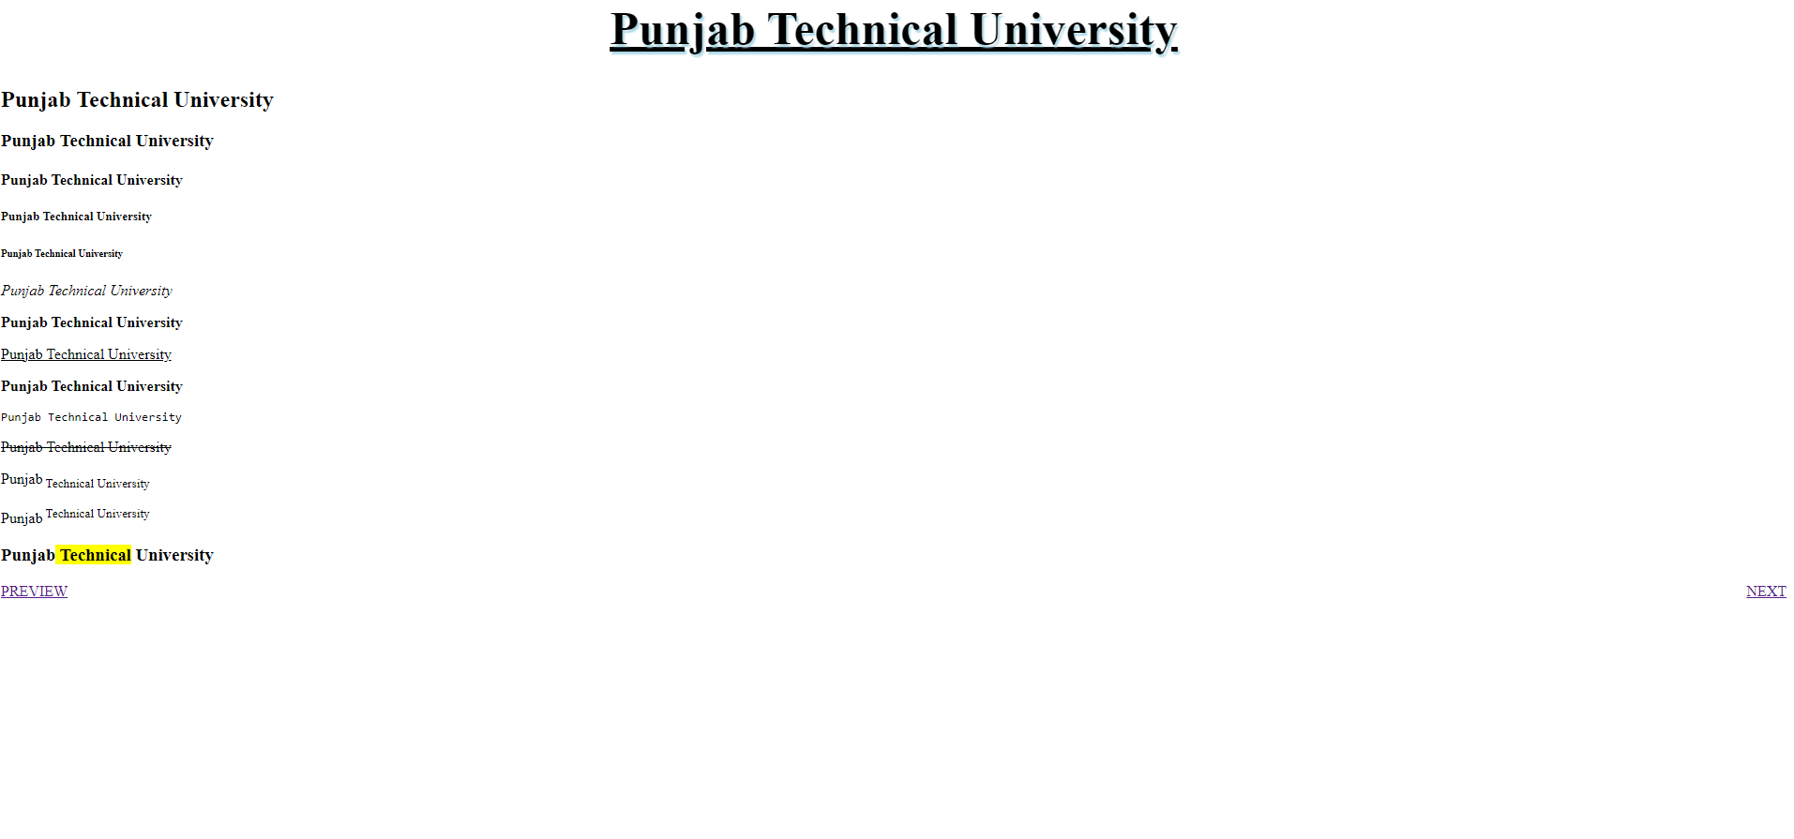

Program no. 6

Design Time Table of your department and highlight most important periods.

<!DOCTYPE html>

<html>

    <head>

    <title>TIME TABLE</title>

    </head>

    <style>

        table,td,th{

            border-collapse: collapse;

            border:1px solid black;

        }

        td{

            text-align: center;

        }

    </style>

    <body>

    <table>

        <tr>

            <th></th>

            <th bgcolor="#0047ffbd" >09:30AM-10:20Am</th>

            <th bgcolor="#0047ffbd" >10:20AM-11:10AM</th>

            <th bgcolor="#0047ffbd" >11:10AM-12:00PM</th>

            <th bgcolor="#0047ffbd" >12:00PM-12:50PM</th>

            <th bgcolor="#0047ffbd" >12:50PM-01:35PM</th>

            <th bgcolor="#0047ffbd" >01:35PM-02:20PM</th>

            <th bgcolor="#0047ffbd" >02:20PM-03:05PM</th>

            <th bgcolor="#0047ffbd" >03:05PM-03:50PM</th>

            <th bgcolor="#0047ffbd" >03:50PM-04:35PM</th>

        </tr>

        <tr>

            <td bgcolor="#0047ffbd"  rowspan="6">MONDAY</td>

            <td bgcolor="yellow"><b>Vibhooti(LR)</b></td>

            <td><b>Information Security</b></td>

            <td bgcolor="yellow"><b>Niraj(SS)</b></td>

            <td bgcolor="grey"; style="color:rgb(31, 30, 30)" rowspan="31"><b>LUNCH BREAK</b></td>

            <td><b>Advanced Java Lab(G2)</b></td>

            <td><b>Web Technologies</b></td>

            <td colspan="2"><b>Advanced Java Lab(G1)</b></td>

            <td><b>Linux T</b></td>

        </tr>

        <tr>

            <td></td>

            <td></td>

            <td></td>

            <td>429</td>

            <td></td>

            <td colspan="2">24</td>

            <td></td>

        </tr>

        <tr>

            <td bgcolor="yellow">CCPD</td>

            <TD bgcolor="green">Ms Gaganpreet</TD>

            <td bgcolor="yellow">CCPD</td>

            <td bgcolor="green">Ms Pragati</td>

            <td bgcolor="green">Ms Gurmandeep Kaur</td>

            <td bgcolor="green" colspan="2">Ms Pragati</td>

            <td bgcolor="green">Mr Naveen</td>

        </tr>

        <tr>

            <td></td>

            <td></td>

            <td></td>

            <td></td>

            <td></td>

            <td colspan="2">Web Technologies Lab (G2)</td>

            <td></td>

        </tr>

        <tr>

            <td></td>

            <td></td>

            <td></td>

            <td></td>

            <td></td>

            <td colspan="2">330</td>

            <td></td>

        </tr>

        <tr>

            <td></td>

            <td></td>

            <td></td>

            <td></td>

            <td></td>

            <td bgcolor="green" colspan="2">Mr Sourav</td>

            <td></td>

        </tr>

        <tr>

            <td bgcolor="#0047ffbd"  rowspan="6">TUESDAY</td>

            <td><b>DAA</b></td>

            <td><b>Advance Java</b></td>

            <td bgcolor="yellow"><b>Anuja(VA)</b></td>

            <td><b>Advance Java Lab(G2)</b></td>

            <td bgcolor="yellow"><b>Sanjay(DS)</b></td>

            <td><b>Information Security</b></td>

            <td colspan="2"><b>Web Technologies Lab(G2)</b></td>

        </tr>

        <tr>

            <td></td>

            <td></td>

            <td></td>

            <td>422</td>

            <td></td>

            <td></td>

            <td colspan="2">220</td>

        </tr>

        <tr>

            <td bgcolor="green">Ms Samriti</td>

            <td bgcolor="green">Dr.Anand Shukla</td>

            <td bgcolor="yellow">CCPD</td>

            <td bgcolor="green">Ms Pragati</td>

            <td bgcolor="yellow">CCPD</td>

            <td bgcolor="green">MS Gaganpreet</td>

            <td bgcolor="green" colspan="2">Mr Sourav</td>

        </tr>

        <tr>

            <td></td>

            <td></td>

            <td></td>

            <td></td>

            <td></td>

            <td></td>

            <td colspan="2">Linux Lab (G1)</td>

        </tr>

        <tr>

            <td></td>

            <td></td>

            <td></td>

            <td></td>

            <td></td>

            <td></td>

            <td colspan="2">24</td>

        </tr>

        <tr>

            <td></td>

            <td></td>

            <td></td>

            <td></td>

            <td></td>

            <td></td>

            <td bgcolor="green" colspan="2">Mr Naveen</td>

        </tr>

        <tr>

            <td bgcolor="#0047ffbd"  rowspan="6">WEDNESDAY</td>

            <td><b>Linux</b></td>

            <td><b>Web Technologies</b></td>

            <td bgcolor="yellow"><b>Naveen(Quant)</b></td>

            <td><b>DAA</b></td>

            <td><b>Advance Java</b></td>

            <td colspan="2"><b>Web Technologies Lab (G1)</b></td>

            <td><b>Advance Java Lab (G1)</b></td>

        </tr>

        <tr>

            <td></td>

            <td></td>

            <td></td>

            <td></td>

            <td></td>

            <td colspan="2">220</td>

            <td>318</td>

        </tr>

        <tr>

            <td bgcolor="green">Mr Naveen</td>

            <td bgcolor="green">Ms Gurmandeep Kaur</td>

            <td bgcolor="yellow">CCPD</td>

            <td bgcolor="green">Ms Samriti</td>

            <td bgcolor="green">Dr.Anand Shukla</td>

            <td bgcolor="green" colspan="2">Ms Gurmandeep Kaur</td>

            <td bgcolor="green">Ms Pragati</td>

        </tr>

        <tr>

            <td></td>

            <td></td>

            <td></td>

            <td></td>

            <td></td>

            <td colspan="2">Linux Lab (G2)</td>

            <td>Library</td>

        </tr>

        <tr>

            <td></td>

            <td></td>

            <td></td>

            <td></td>

            <td></td>

            <td colspan="2">24</td>

            <td></td>

        </tr>

        <tr>

            <td></td>

            <td></td>

            <td></td>

            <td></td>

            <td></td>

            <td bgcolor="green" colspan="2">Mr Naveen</td>

            <td></td>

        </tr>

        <tr>

            <td bgcolor="#0047ffbd"  rowspan="6">THURSDAY</td>

            <td><b>Web Technologies</b></td>

            <td><b>Linux</b></td>

            <td><b>DAA</b></td>

            <td><b>Advance Java</b></td>

            <td><b>Information Security</b></td>

            <td colspan="2"><b>Web Technologies Lab (G1)</b></td>

            <td><b>Advance Java Lab (G1)</b></td>

        </tr>

        <tr>

            <td></td>

            <td></td>

            <td></td>

            <td></td>

            <td></td>

            <td colspan="2">220</td>

            <td>318</td>

        </tr>

        <tr>

            <td bgcolor="green">Ms Gurmandeep Kaur</td>

            <td bgcolor="green">Mr Naveen</td>

            <td bgcolor="green">Ms Samriti</td>

            <td bgcolor="green">Dr.Anand Shukla</td>

            <td bgcolor="green">Ms Gaganpreet</td>

            <td bgcolor="green" colspan="2">Ms Gurmandeep Kaur</td>

            <td bgcolor="green">Ms Pragati</td>

        </tr>

        <tr>

            <td></td>

            <td></td>

            <td></td>

            <td></td>

            <td></td>

            <td colspan="2">Linux Lab (G2)</td>

            <td>Library</td>

        </tr>

        <tr>

            <td></td>

            <td></td>

            <td></td>

            <td></td>

            <td></td>

            <td colspan="2">24</td>

            <td></td>

        </tr>

        <tr>

            <td></td>

            <td></td>

            <td></td>

            <td></td>

            <td></td>

            <td bgcolor="green" colspan="2">Mr Naveen</td>

            <td></td>

        </tr>

        <tr>

            <td bgcolor="#0047ffbd" rowspan="6">FRIDAY</td>

            <td><b>Linux</b></td>

            <td><b>Web Technologies</b></td>

            <td><b>DAA</b></td>

            <td><b>Advance Java</b></td>

            <td bgcolor="yellow"><b>Abhishek Python</b></td>

            <td><b>Information Security</b></td>

            <td colspan="2"><b>Linux Lab (G1)</b></td>

        </tr>

        <tr>

            <td></td>

            <td></td>

            <td></td>

            <td></td>

            <td></td>

            <td></td>

            <td colspan="2">24</td>

        </tr>

        <tr>

            <td bgcolor="green">Mr Naveen</td>

            <td bgcolor="green">Ms Gurmandeep Kaur</td>

            <td bgcolor="green">Ms Samriti</td>

            <td bgcolor="green">Dr.Anand Shukla</td>

            <td bgcolor="yellow">CCPD</td>

            <td bgcolor="green">Ms Gaganpreet</td>

            <td bgcolor="green" colspan="2">Mr Naveen</td>

        </tr>

        <tr>

            <td></td>

            <td></td>

            <td></td>

            <td></td>

            <td></td>

            <td></td>

            <td colspan="2">Advance Java (G2)</td>

        </tr>

        <tr>

            <td></td>

            <td></td>

            <td></td>

            <td></td>

            <td></td>

            <td></td>

            <td colspan="2">220</td>

        </tr>

        <tr>

            <td bgcolor="green"></td>

            <td bgcolor="green"></td>

            <td bgcolor="green"></td>

            <td bgcolor="green"></td>

            <td bgcolor="green"></td>

            <td bgcolor="green"></td>

            <td bgcolor="green" colspan="2">Ms Pragati</td>

        </tr>

    </table>

    <a href="program5.html">PREVIEW</a>

    <a href="program7.html" style="float:right">NEXT</a>

    </body>

</html>

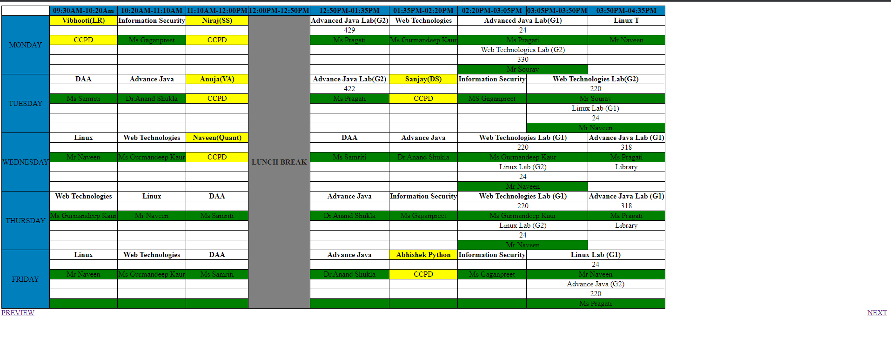

**Program no.7**

Use Tables to provide layout to your web page.

<!DOCTYPE html>

<html>

    <head>

        <title>layout</title>

        <style>

             table{

            width:100%;

             }

             .c{

                background-color: #55c313;

                padding: 20px 0px;

                text-align: center;

             }

             #k{

                background-color: #99a9b4;

                padding: 20px 0px;

                text-align: center;

             }

             .jk th{

                padding:200px 0px;

             }

             .jk .a{

                background-color:#0fbc6b;

             }

             .b{

                background-color: #1319cc;

             }

             .d{

                background-color: #df6ba1;

             }

        </style>

        <body>

            <table>

                <tr>

                    <th colspan="3" class="c">LAYOUT</th>

                </tr>

                <tr class="jk">

                    <th class="a">HTML</th>

                    <th class="b">CSS</th>

                    <th class="d">JAVASCRIPT</th>

                    <MARquee> <h3>WELCOME  TO WEB TECHNLOGY</h3></MARquee>

                </tr>

                <tr>

                    <th colspan="3" id="k">WEB PAGE</th>

                </tr>

            </table>

            <a href="program6.html">PREVIEW</a>

    <a href="program8.html" style="float:right">NEXT</a>

        </body>

    </head>

</html>

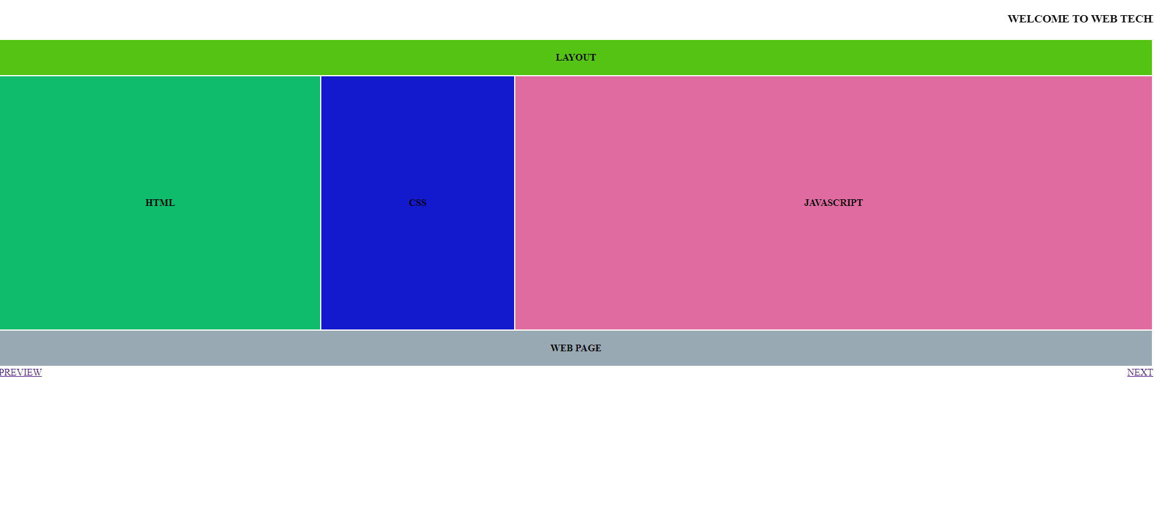

**Program no.8**

Embed Audio and Video into your web page.

<!DOCTYPE html>

<html>

    <head>

        <title> Audio and video</title>

        <style>

            table{

                width: 100%;

                margin-top: 10%px;

            }

            .a{

                padding: 20px;

                background-color: aqua;

            }

            .b{

                padding:200px;

                background-color: gray;

            }

            .c{

                background-color: navajowhite;

                padding:200px;

            }

            .d{

                background-color: cadetblue;

                padding: 20px;

            }

            </style>

        </head>

        <body>

            <table>

                <tr>

                    <th colspan="2" class="a"><b> Audio and Video  </b></th>

                </tr>

                <tr>

                    <th class="b" ><audio src="shree.mp3" controls></audio></th>

                    <th class="c">Video</th>

                </tr>

                <MArquee><b>WELCOME TO AUDIO AND VIDEO LAYOUT</b></MArquee>

                <tr>

                    <th colspan="2" class="d"><u>ArunTiwari(2235545) </u></th>

                </tr>

            </table>

            <a href="program7.html">PREVIEW</a>

    <a href="" style="float:right">NEXT</a>

        </body>

</html>

